IF YOU ENOUNTER ANY ISSUES WITH ACCESSING OR SUBMITTING YOUR ID, CALL THE IS HELP DESK @ 1-800-387-1833
From External Website (employees.cpr.ca)
If signing onto CP Station externally, you must access the AV bid form from the employees.cpr.ca landing page. The link has been added to the bottom (AV link will replace the Mileage Date Bid link pictured below). Once you click on the link, proceed to step 5.
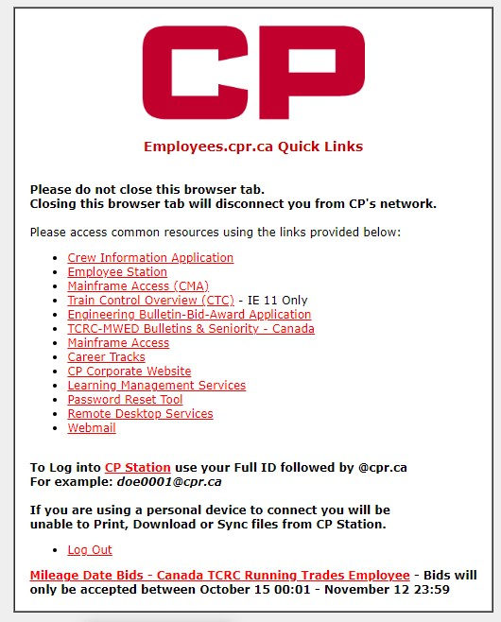

Step 1
CTRL + F3 to take you to CP Station
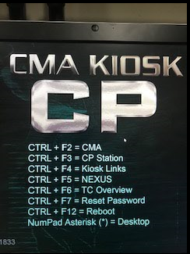

Step 2
Click the CP Logo at the top left of CP Station, then click on the arrow beside ‘Work Tools’, then click the arrow beside the next ‘Work Tools’ and then select ‘Frequently Accessed Links’
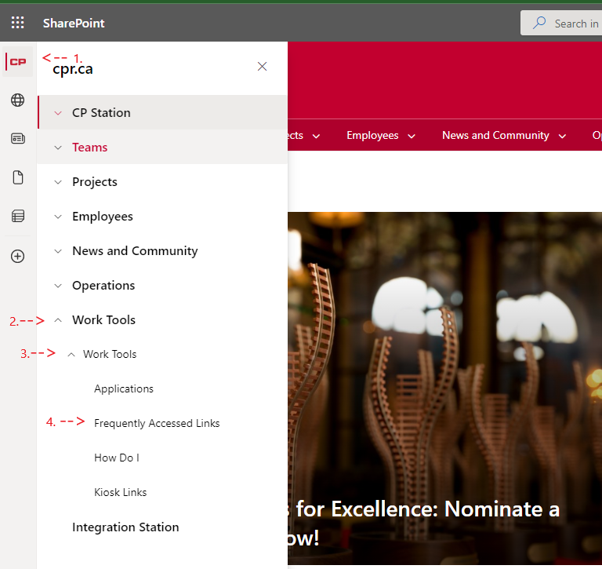

Step 3
Scroll down the list of Frequently Accessed Applications and click on ‘Crew Information’
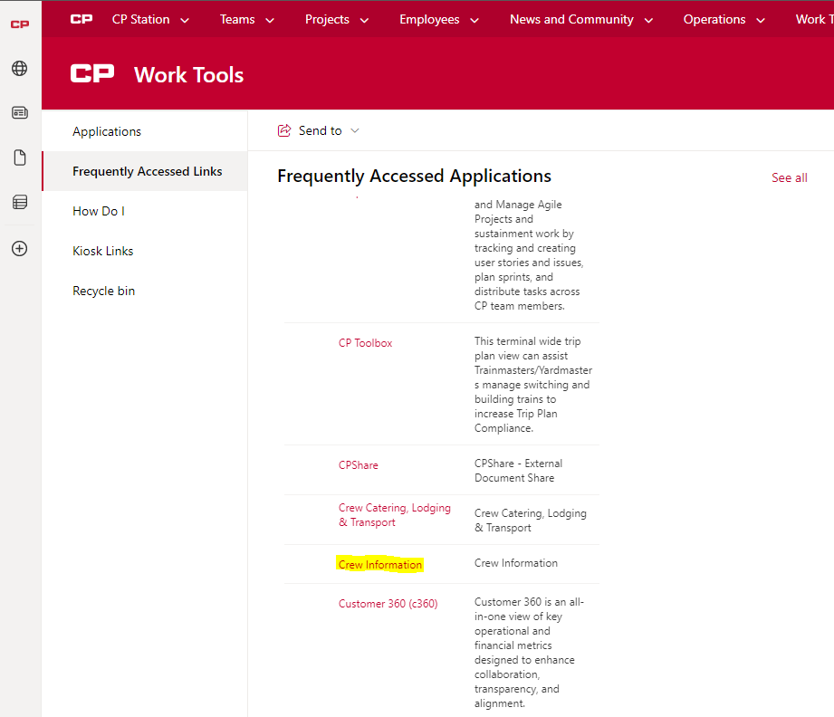

Step 4
Click the link “2024 AV Bid Form – TCRC Running Trades Employee” located under the crew information link (AV Bidding link will replace the mileage date bid link in the picture below). This link will be hosted in the same place as last year.
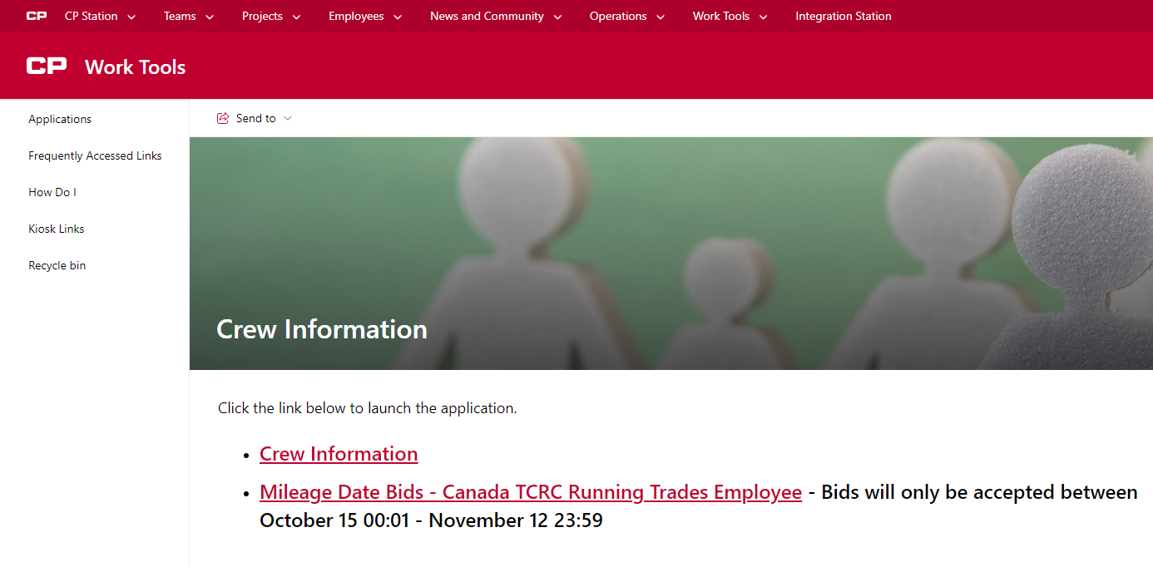
Step 5
You will see this form to be filled out by each employee wanting submit an AV bid form
- You must fill out your employee number in the “Employee CP ID#” field
- You must fill out an email address in order to receive an email confirmation of your bid. This can be to any valid email address, internal or external
- You must fill out your last name in the “Employee Last Name” field
- You must select “YES” in the user agreement to verify you are submitting a bid on your own behalf and not for another employee
- Once these 4 fields are filled in, click the AV Bid Region drop down box and select the region (East/West) you belong to.

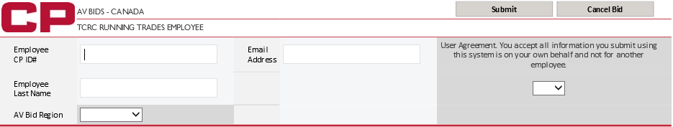

Your information should be entered before you continue to enter your AV choices
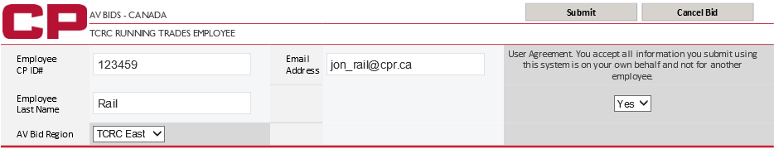
IF YOU ENOUNTER ANY ISSUES WITH ACCESSING OR SUBMITTING YOUR ID, CALL THE IS HELP DESK @ 1-800-387-1833

Step 6 (TCRC EAST)

- Begin to enter your choices in the “AV Start Week” box
- Only 1 choice at a time can be added
- After each choice is entered into the box, click the “Add to Week” button to add the choice to your bid form
- Only numbers 1 – 52 will be accepted within the form
- If you need to clear your last choice, click the “Clear Week” button. Only your last choice can be cleared so if you have entered 10 choices and need to clear your 5th choice, you will need to clear all choices in between choices 5 and 10 to get back to choice 5.
- Once you have added all the choices you desire, click “submit” in the top right hand corner
- Once Submitted, please close the browser window

Example TCRC East:
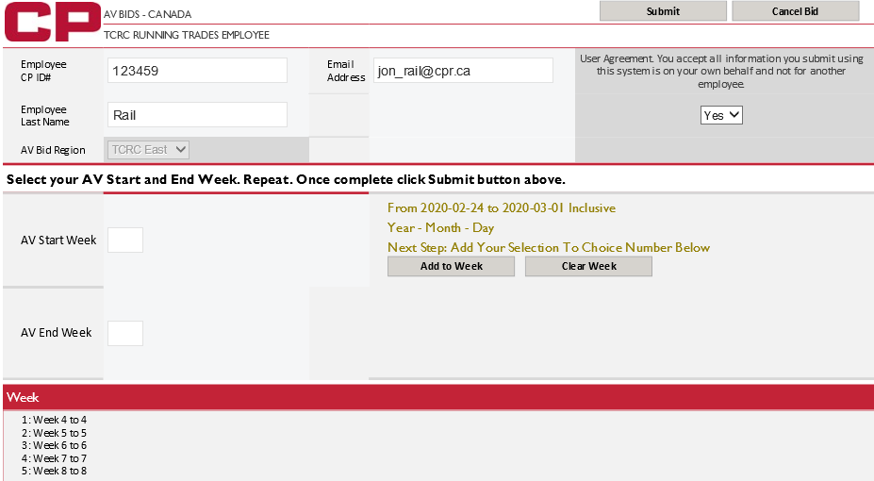

Step 6 (TCRC WEST)

- Begin to enter your choices in the “AV Start Week” box by entering the week you wish to start your vacation
- If entering multiple weeks in one choice, please enter the week number in which you’d like to be your final week of vacation in the “AV End Week” box
Example: I want weeks 1/2/3 inclusive, I will enter 1 in the AV start week box and I will enter 3 in the AV end week box. This will reflect me bidding 3 weeks, 1/2/3.
- You will see ‘Early Option’ and ‘Late Option’ boxes next to the ‘AV Start Week’ box to allow you to select with each choice if you would like to choose the early/late option for a choice.
- After each choice is entered into the box(s), click the “Add to Split” button to add the choice to your bid form to the applicable split in which you’d like the choice added
Example: I want weeks 51/52 added to split 2, I enter 51 in the AV start week box and I will enter 52 in the AV end week box, then hit the ‘Add to Split 2” button.
- You can add choices to any split at any time as long as you have at least 1 choice already made for that split or the split previous to that split.
- Only numbers 1 – 52 will be accepted within the form
- If you need to clear your last choice, click the “Clear Split” button of the applicable split in which you wish to clear your most recent selection. Only your last choice in any given split can be cleared so if you have entered 10 choices and need to clear your 5th choice, you will need to clear all choices in between choices 5 and 10 to get back to choice 5.
- Once you have added all the choices you desire, click “submit” in the top right hand corner
- Once submitted, please close the browser window

Example TCRC West:
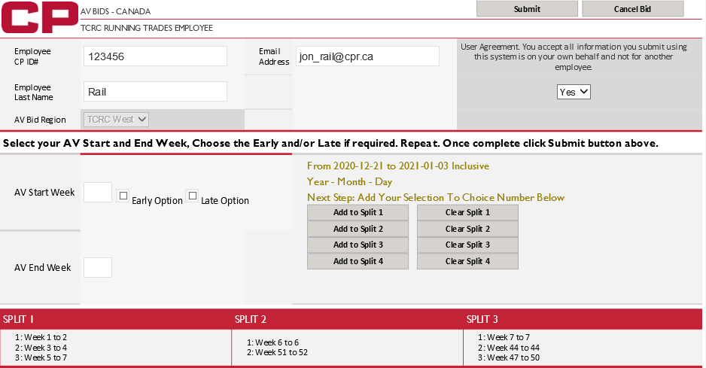

You will see this screen once your bid has been successfully submitted
If you need to submit another bid, you will need to close your browser completely and go back through the same path to re-open the link.

- You will receive the below email confirmation. Please ensure you receive the confirmation email and you review all information you’ve entered (employee number, bid choices, etc.) is accurate.
- If you want to make any changes or don’t receive a confirmation email, you can submit another bid. If you need to submit another bid, you will need to close your browser completely and go back through the same path to re-open the link.
- Only your most recent bid will be accepted.

